PSSI Science Project Reporting Template

️ | The PSSI Implementation Team is compiling a technical report to demonstrate the important research and advancements made by the Science Branch through the PSSI funding. The technical report will include a 3-4 page summary (including graphics and figures) for each project to show their key results and findings. Please fill in the following fields and sections for your project to be included in the report. Feel free to include and draw from any reports or presentations previously created through your research.  A plain language science bulletin will also be created to follow up on last year’s “DFO Pacific Region Science Bulletin, 2024. New research and monitoring for Pacific salmon and their ecosystems.” While the first bulletin introduced project backgrounds, methods, and timelines, this new bulletin will highlight the projects’ results, key findings, and conclusions with links to reports and data available. The bulletin will include a 1-2 page summary for each project gleaned from the content entered below.  ️ Completed forms are due January 7, 2026.  *Please include or send separately any graphics or pictures (with photo credits) that will help promote the projects.

PART 1: PROJECT METADATA

General Project Information
Project ID (number) | Project Title
0000  NA- funded under Pillar 3 | Enhanced Mark Selective Fishery (MSF) Monitoring (including a Chinook Reference Fishery)
Project Leads | Collaborations and External Partners
Erin Rechisky; Philip Lemp | Sport Fishing Institute of British Columbia (SFI)
Location (if applicable) | Sport Fishing Institute of British Columbia (SFI)
Southern BC | Sport Fishing Institute of British Columbia (SFI)

Geographic and Stock Information
Salmon species (if applicable) | Waterbodies (if applicable)
Chinook Salmon (Oncorhynchus tshawytscha) | Bute Inlet (PFMA 13), Toba Inlet (PFMA 15), Sechelt Inlet (PFMA 16), Gulf Islands/Saanich Inlet (PFMAs 17,18,19), Victoria & Haro Straight (PFMA 19), Howe Sound (PFMA 28). See (Figure 1).
Life history phases (if applicable) | Region
Adult (Ocean Phase) | Southern British Columbia
Stock (if applicable) | Population (if applicable)
All Chinook Stocks Present | All
Conservation Unit (if applicable)
Click or tap here to enter text.

🧰 PART 2: PROJECT METRICS

Project Outputs
Include any anticipated outputs denoted as (in progress). Please include links to any outputs available online so they can be referenced in the report.
List scientific publications and technical reports (with links)
2023 Data Report: Enhanced monitoring of recreational chinook salmon mark-selective fisheries in south coast BC tidal waters : reference fishery, 2023
2024 Data Report: Enhanced Monitoring of Recreational Chinook Salmon Mark-Selective Fisheries in South Coast BC Tidal Waters: Reference Fishery, 2024

2025 Data Reports Expected Spring 2026.

Comparative analysis between reference fishery results and creel estimates expected Summer 2026.
List datasets generated (with links)
2023, 2024 Data Available on Open Canada: South Coast Area BC Chinook Reference Fishery Biological Data - Open Government Portal
2025 Data to be added in Spring 2026

Describe dataset locations and data management systems
Biological data and associated metadata are stored on a secure DFO internal data base system (CREST), quality-checked, version-controlled, and archived by South Coast Stock Assessment. Final datasets are publicly released through the Government of Canada Open Data Portal in accordance with DFO open data policies.
List code, programs, or other software created (with links)
The Chinook Reference Fishery dashboard allows one to explore hatchery mark rates, size distributions, GSI results, and more using the full database of Chinook samples collected during the 3-year project. The dashboard currently includes data through 2024; 2025 stock ID results will be added once they become available.

Link: Chinook Reference Fishery Dashboard | Fisheries Map Gallery

List communication or social media products
- DFO Pacific Region Science Bulletin (2024): New research and monitoring for Pacific salmon and their ecosystems.
- Media coverage: The Chinook reference fishery was featured in at least two Island Fisherman Magazine articles (no DFO authorship) including this one: Chinook MSF - Key Insights and Reference Data Explained
- Technical and stakeholder presentations: Reference fishery results were presented and discussed at:
  - Fraser & Approach Salmon Fisheries Forums Joint Technical Working Group (JTWG)
  - Nuu-chah-nulth Tribal Council (NTC) Joint Technical Working Group
  - Area 25 Harvest Round Table
  - Sport Fishing Institute of BC (SFI) Conference
  - Sport Fishing Advisory Board (SFAB) Catch Monitoring Working Group meetings
  - Avid Angler Annual General Meeting (AGM)
  - Island Marine Aquatic Working Group Technical Meeting (IMAT)
  - Pacific Salmon Strategy Initiative (PSSI) Symposium

List and describe samples collected/analyzed (number of samples)
6,361 Chinook salmon were captured, sampled, and released (2023-2025). Non-lethal tissue samples were collected for every fish captured and most were sent to the molecular genetics lab at the Pacific Biological Station to determine stock of origin. Approximately 5000 fish were identified.

List and describe large capital assets or equipment acquired
None

PART 3: WRITTEN CONTENT

Highlights
Please summarize in 2-3 bullets:
- The main idea of the project
- Key findings
- Implications of these findings for salmon and decision-makers
- For a more technical audience, but still as plain language as possible
- The Chinook reference fishery was a fishery-independent study to assess estimates produced by DFO’s fishery-dependent recreational fishery catch monitoring (creel) program particularly for mark-selective fisheries (MSFs). This included catch by size class, hatchery mark rate, and stock composition of unmarked Chinook that would otherwise be released at sea in a pure MSF.
- The reference fishery provided an unbiased baseline of the Chinook composition vulnerable to the recreational fishery, something that creel data alone cannot fully provide, and is therefore a valuable tool for evaluating active MSFs and supporting future MSF design.
- Results indicate that core assumptions underlying creel estimates in MSFs need to be explicitly considered in fishery planning, as reliance on creel data alone can misrepresent impacts on stocks of concern and affect management decisions.

Background
Please provide 1-2 paragraphs to summarize
- The relevant biological, environmental, and/or management context
- What knowledge gap or demand were you trying to fill?
- Collaboration and partner relationships
Mark-selective fisheries (MSFs) have been implemented as a management tool to shift exploitation away from natural-origin Chinook salmon toward hatchery-origin fish; the latter often have their adipose fin removed at the hatchery and are referred to as “marked”. In pure MSFs, unmarked stocks are legally required to be released at sea and thus are unavailable to dockside sampling. Following widespread recreational Chinook closures in 2019, a series of mixed-bag and pure MSFs were progressively introduced across southern British Columbia between 2020 and 2024, increasing the need for robust monitoring to evaluate their impacts.

During consultations, First Nations and stakeholders raised concerns about potential encounters with Chinook stocks of concern in MSFs. In response, the Pacific Salmon Strategy Initiative (PSSI) supported enhanced monitoring under the Harvest Transformation pillar, including expanded creel surveys and the development of a Chinook reference fishery. The reference fishery was designed to address key data gaps by independently assessing mark rates, legal rates (i.e., proportion of legal size Chinook encountered), and stock composition—particularly for unmarked fish in pure MSFs—aligning with recommendations from the Pacific Salmon Commission to improve monitoring of MSFs. This work was made possible through collaboration between DFO and the Sport Fishing Institute of BC, with support from a BC Salmon Restoration and Innovation Fund grant that enabled the use of charter vessels and local guide expertise.

️ Methods and Findings
Please insert a few paragraphs to summarize:
- Main methods used
- Products and tools produced
- Advancements in methodology, technology, and application
- Advancements in communication and knowledge transfer
- Key results and information generated
Sampling operations were designed to closely mirror typical recreational Chinook salmon fisheries to ensure that sampled fish were representative of those vulnerable to capture by recreational anglers. Reference fishing trips were conducted by experienced local guides operating as standard charter excursions. A trained DFO sampler was assigned to each vessel to document and sample all Chinook salmon encountered. Activities were restricted to MSF open areas or predefined sampling boundaries (Figure 1). While guided fishing typically results in higher catch rates than unguided effort, the objective of the reference fishery was not to estimate fishing effort but maximize catch in order to characterize catch composition, mark rates, and stock composition of Chinook encountered by the recreational fishery. In total, 780 boat days of Chinook sampling were completed over the 3-year study.

Chinook salmon were identified at the boat’s side, briefly brought aboard for sampling, and released immediately following best-practice handling procedures consistent with DFO guidelines. All non-Chinook species were released immediately and recorded. For each Chinook sampled, data collected included catch location, time to landing, fork length, adipose fin clip status, and a tissue sample for stock ID (genetic stock identification (GSI) and parentage-based tagging (PBT; Beacham et al., 2022)). Results are presented at the stock region level, where assignment confidence is highest and alignment with Canadian stock management units is strongest (Beacham et al., 2018).

This project generated a novel, fishery-independent dataset and provided unbiased baseline information on the stock composition (Figure 3), mark rate (Figure 2), and legal-size rate of Chinook salmon vulnerable to the recreational fishery, regardless of size or mark status. The dataset also includes detailed spatial and operational metadata linked to each encounter, enabling improved interpretation of results and supporting future analyses. Products from this work include publicly released biological datasets, technical reports, and dashboards that enhance transparency, support management evaluation of MSFs, and improve communication of results to partners and stakeholders.

Insights
Please insert a few paragraphs to summarize:
- What this project has added to knowledge about salmon populations, health, or ecosystems.
- How this project informs salmon management:
  - decisions
  - policy guidance
  - trade-offs
  - planning
- Addition of knowledge to understanding:
  - limiting factors/stressors/threats/ pathways of effects/risks
  - biologically significant thresholds
  - cumulative impacts
- Sources of uncertainty
The Chinook reference fishery has substantially advanced understanding of Chinook salmon populations encountered by recreational fisheries by providing a baseline of biological data. By sampling Chinook regardless of size or mark status, this project has generated unbiased estimates of stock composition, mark rates, and legal-size rates that are not otherwise observable during mark-selective fishery (MSF) monitoring. These data improve understanding of which stocks are exposed to recreational fishing activity, including stocks of concern that are can be poorly represented by dockside sampling programs in MSFs (Figure 3).

The results directly inform decision-making, planning, and policy guidance related to MSFs. The data reduce uncertainty around the impacts of MSFs on vulnerable Chinook stocks and allow managers to critically evaluate assumptions underlying current catch monitoring methods, particularly creel-based estimates (see Figure 2). This improved evidence base supports more informed trade-offs between fishing opportunity and conservation objectives, helps align MSF design with realistic monitoring capacity, and contributes directly to Integrated Fisheries Management Plan (IFMP) development and briefings to the Minister on key management decisions.

The project also advances understanding of cumulative impacts and pathways of effect by providing detailed encounter data that can be linked to regulations, fishing dynamics and compared to standard catch monitoring methods. In doing so, it highlights key limitations of existing monitoring tools and identifies where biologically meaningful thresholds and risks may be underestimated due to data gaps. Importantly, MSFs inherently constrain the ability to observe impacts on all stocks encountered in the fishery; the reference fishery partially overcomes this limitation and clarifies where residual uncertainty remains.

Overall, the primary outcome of the Chinook reference fishery is a meaningful reduction in uncertainty in fisheries management. In the absence of robust data, management must rely heavily on the precautionary approach; this project provides the empirical evidence needed to move from precaution driven by uncertainty to precaution informed by data. The insights gained will continue to guide future MSF planning, help determine reference fishery requirements through collaborative processes, and support ongoing improvements to monitoring frameworks based on lessons learned from this unique and valuable dataset.

Despite the substantial reduction in uncertainty achieved through the reference fishery, some limitations remain. Analytical power can be constrained in certain spatial and temporal strata where sample sizes are low, particularly for stocks that occur at very low prevalence. Even with robust sampling effort, rare Chinook stocks may not be detected, and absence of detection should not be interpreted as absence of exposure. The reference fishery is not a census, but rather a robust, fishery independent sampling program designed to complement existing creel monitoring. As such, it cannot fully resolve all sources of uncertainty inherent in recreational catch monitoring, but it provides critical context for interpreting estimates and understanding the limitations and assumptions of current monitoring tools.

⏩ Next Steps
Please insert 1-2 paragraphs to summarize:
- Remaining knowledge gaps and recommendations for future studies
- How can/should the project findings be operationalized for salmon conservation and management?
Key remaining knowledge gaps relate to understanding when and where a reference fishery is necessary versus when existing creel and complementary monitoring tools are sufficient to evaluate MSFs. Future work should focus on using the reference fishery baseline to formally test assumptions underlying creel-based catch and encounter estimates, identify strata where monitoring power is limited, and define thresholds for acceptable uncertainty in MSF evaluations. This will help determine the conditions under which a reference fishery provides the greatest value and where alternative monitoring approaches may be appropriate.

Project findings should be operationalized by integrating reference fishery outputs directly into MSF planning and assessment processes. The reference fishery is an effective tool for evaluating active MSFs and should be considered strategically in future MSF design, particularly for fisheries with high conservation risk or limited observability. Moving forward, closer collaboration between Stock Assessment and Fisheries Management is recommended to align MSF design with monitoring capacity, and to jointly determine reference fishery requirements based on management objectives, data needs, and evaluation metrics. This approach will support efficient use of resources while ensuring MSFs are implemented and assessed using the best available data.

📈 Tables and Figures
Please provide captions and numbering for any tables and figures. Graphics can be copied below or e-mailed separately.
- Include a brief caption with each figure and table in the box below
- Number each table and figure, and include references in the above sections where appropriate.
- 1-3 figures are recommended per project
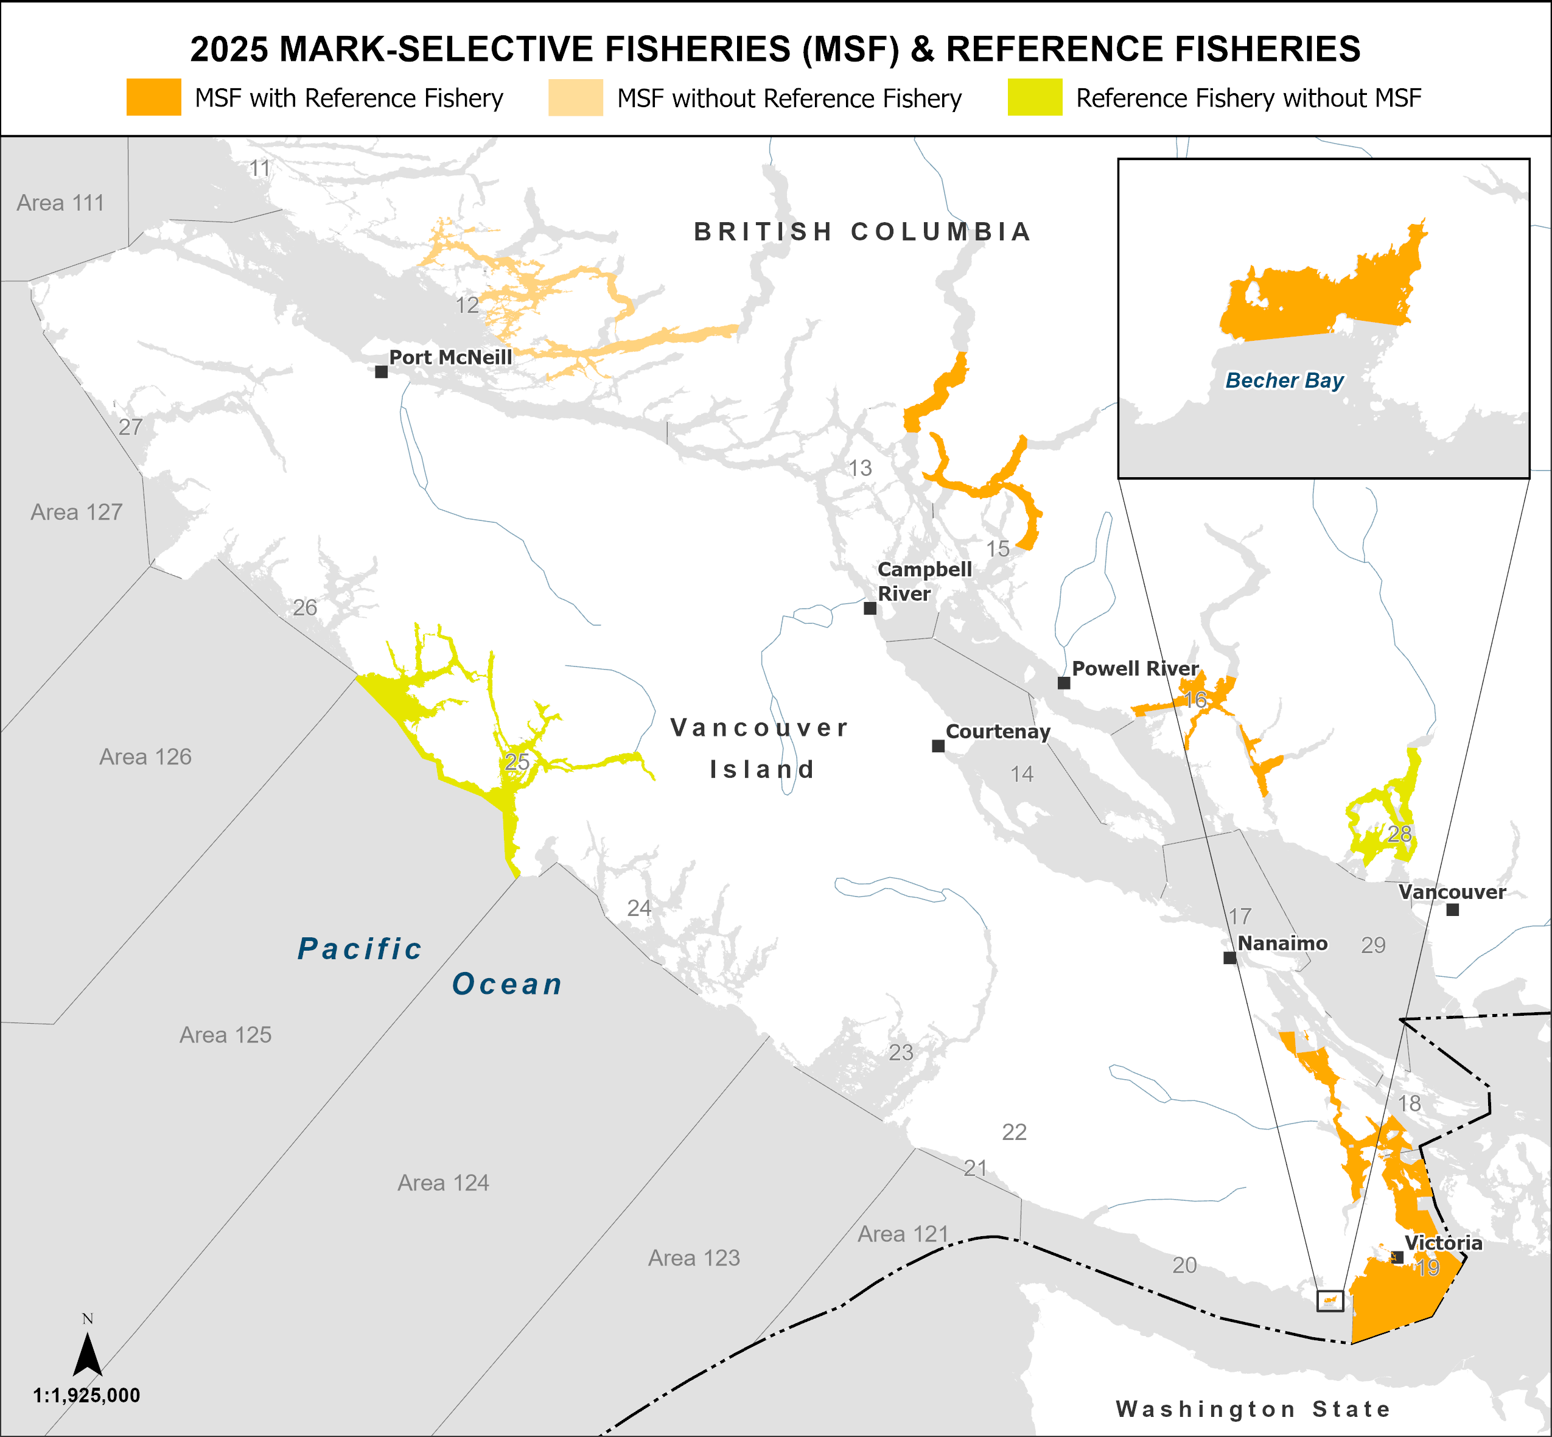
Figure 1. Map of MSFs with Chinook reference fisheries, MSFs without Chinook reference fisheries and areas without MSFs but with Chinook reference fisheries in the DFO South Coast Area in 2025. Note the reference fishery in Area 25 was not funded by PSSI.

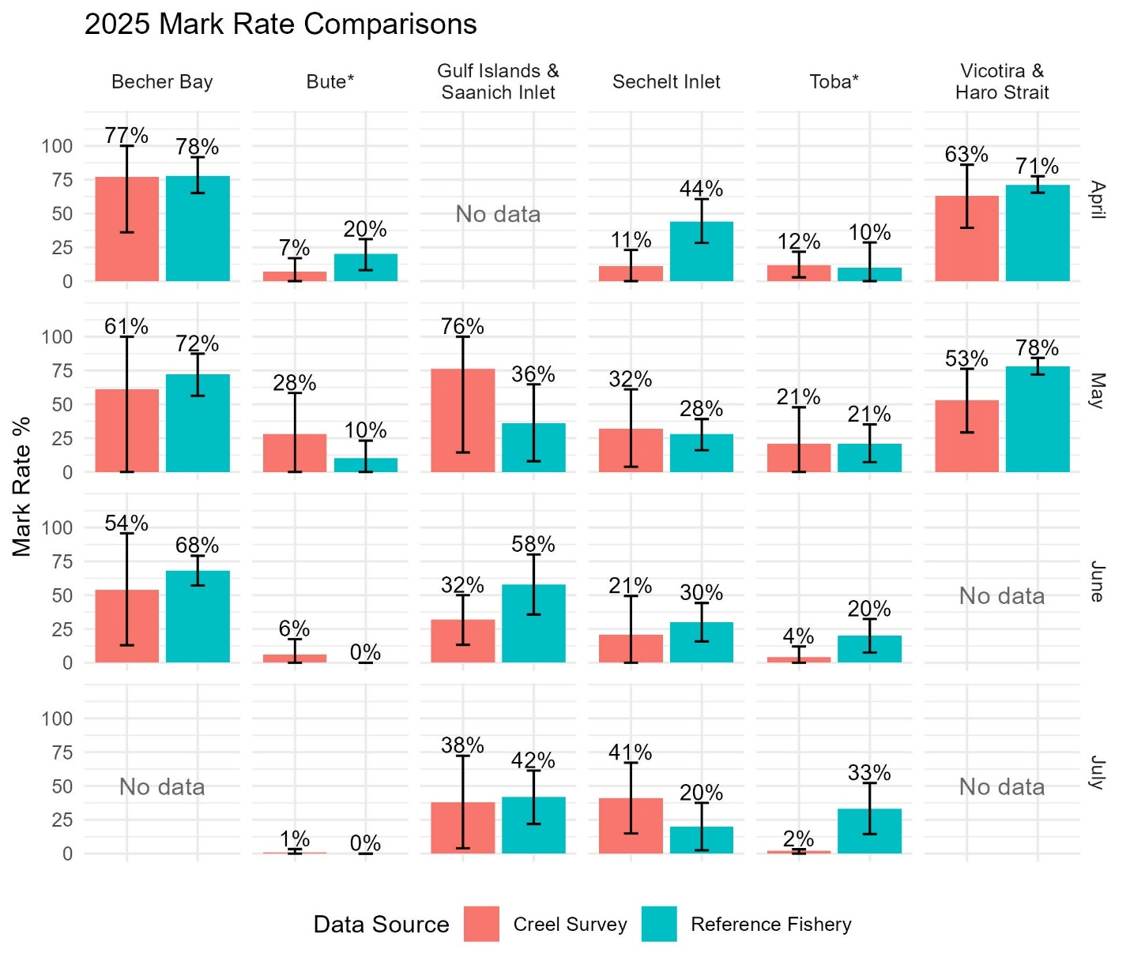
Figure 2. Comparison of creel-estimated mark rates (red) and reference fishery-observed mark rates (blue) by month and MSF in 2024. Error bars represent 95% confidence intervals. “NA” indicates the fishery was not open, while “No data” means the fishery was open but the reference fishery was not operating. Asterisks (*) indicate mixed-bag MSFs (Bute and Toba Inlets); all others are pure mark-selective fisheries.

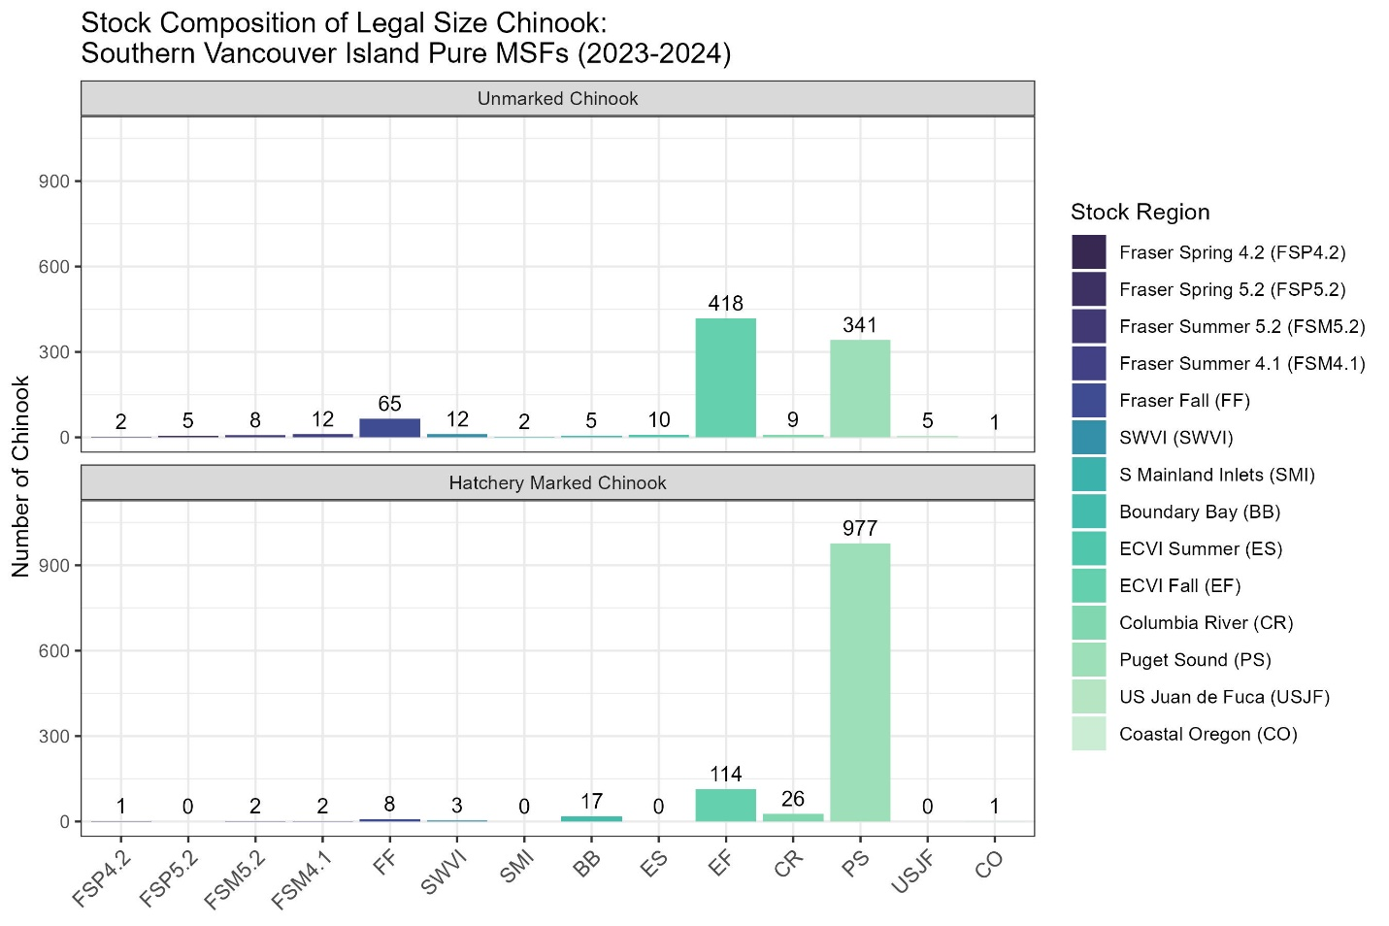
Figure 3: Stock composition of legal sized Chinook salmon by month and mark status in all reference fisheries conducted within Southern Vancouver Island. Numbers at the top of each bar are the sample size of Chinook caught in the reference fishery in each category.

📈 References
Include full references for any publications referenced in other sections. Please format references in Harvard style according to Instructions to Authors for the Canadian Journal of Fisheries and Aquatic Sciences, at Canadian Science Publishing.
Beacham, T.D., Wallace, C., MacConnachie, C., Jonsen, K., McIntosh, B., Candy, J.R., and Withler, R.E. 2018. Population and individual identification of Chinook salmon in British Columbia through parentage-based tagging and genetic stock identification with single nucleotide polymorphisms. Canadian Journal of Fisheries and Aquatic Sciences 75(7): 1096–1105. https://doi.org/10.1139/cjfas-2017-0168

Beacham, T.D., Jonsen, K., Sutherland, B.J.G., Ramshaw, B., and Rondeau, E.B. 2022. Parentage-based tagging and genetic stock identification applied to assessment of mixed-stock fisheries and hatchery broodstocks for Chinook salmon in British Columbia, Canada. Fisheries Research 253: 106369. https://doi.org/10.1016/j.fishres.2022.106369

